APPLICATION FORM
2027-28

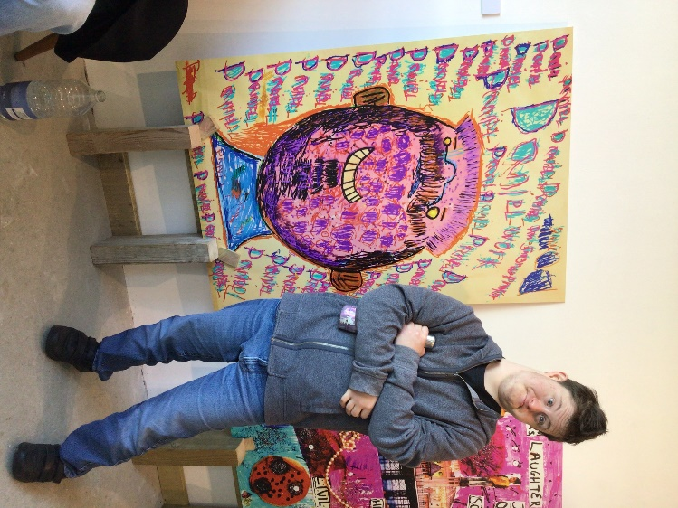

Contents
APPLICATION FOR A PLACEMENT AT ORPHEUS 3
TYPE OF PLACEMENT APPLIED FOR AT ORPHEUS 3
SECTION 1: APPLICANT PERSONAL DETAILS 3
SECTION 2: PERSONAL STATUS 4
SECTION 3: PARENT/CARER CONTACT DETAILS 4
SECTION 4: MENTAL CAPACITY ASSESSMENT 5
SECTION 5: LASTING POWER OF ATTORNEY 5
SECTION 6: COURT OF PROTECTION 5
SECTION 7: LOCAL AUTHORITY (LA) CONTACT DETAILS 6
This is me 7
SECTION 8: APPLICANT SPECIAL EDUCATIONAL NEEDS 10
SECTION 9: YOUR ADDITIONAL SUPPORT 11
SECTION 10: YOUR HEALTH 12
SECTION 11: PRESCRIBED MEDICATION 13
This is me 14
SECTION 12: YOUR PERSONAL SUPPORT DURING THE COLLEGE DAY 16
SECTION 13: LIFESKILLS (SUPPORTED HOUSING APPLICANTS ONLY) 17
SECTION 14: MOVING AND HANDLING (SUPPORTED HOUSING APPLICANTS ONLY) 19
MY CONSENT 21

APPLICATION FOR A PLACEMENT AT ORPHEUS
Date of application

Proposed year of entry | 2027

TYPE OF PLACEMENT APPLIED FOR AT ORPHEUS
Day placement where the student will live at home |  | ☐
Day placement with supported housing where the student will live at Orpheus |  | ☐

SECTION 1: APPLICANT PERSONAL DETAILS
Last name / Family name
First name
Preferred name

Date of Birth
Language spoken

Home address and postcode

Name of current school / college or provider

Applicant email address

SECTION 2: PERSONAL STATUS
Are you adopted, fostered, living in care or under special guardianship?

SECTION 3: PARENT/CARER CONTACT DETAILS
Contact details | 1 | 2
Name
Relationship to applicant
Home address and postcode

Email address

Mobile telephone number
Work telephone number
Parental marital status (if appropriate)

Please state which contact(s) can be communicated with as appropriate | Yes ☐ No ☐ | Yes ☐ No ☐

SECTION 4: MENTAL CAPACITY ASSESSMENT
Have you had a Property and Financial Mental Capacity assessment completed? | Yes ☐ No ☐  If yes, please list and attach details of Assessment or Reports
Have you had a Health and Welfare Mental Capacity assessment completed? | Yes ☐ No ☐  If yes, please list and attach details of Assessment or Reports

SECTION 5: LASTING POWER OF ATTORNEY
Is there a Lasting Power of Attorney in place? | Lasting Power of Attorney - Property & Financial  Yes ☐ No ☐  If yes, please attach copy of Lasting Power of Attorney documents
Is there a Lasting Power of Attorney in place? | Lasting Power of Attorney - Health & Welfare  Yes ☐ No ☐  If yes, please attach copy of Lasting Power of Attorney documents
Lasting Power of Attorney contact details:

SECTION 6: COURT OF PROTECTION
Is there a Court of Protection order in place? | Court of Protection Deputy - Property & Financial  Yes ☐ No ☐  If yes, please attach copy of Court of Protection documents
Is there a Court of Protection order in place? | Court of Protection Deputy - Health & Welfare  Yes ☐ No ☐  If yes, please attach copy of Court of Protection documents
Is there a Court of Protection order in place? | Court of Protection Appointee – Administer state benefits only  Yes ☐ No ☐  If yes, please attach copy of Court of Protection documents

SECTION 7: LOCAL AUTHORITY (LA) CONTACT DETAILS
Contact details | LA Education Caseworker | LA Social Worker
Local Authority e.g., Surrey
Name

Email address

Telephone number and extension (if known)

This is me 

Hello! Help us get to know you by filling out these boxes.
You can write, draw or add pictures

  Music I listen to |   What I watch | 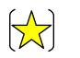  My favourite subject
My family |   My friends |   My boyfriend or girlfriend
  Things I like |   Things I don’t like |   Things I am great at
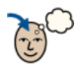  Things I would like to learn more about |   Who I live with | 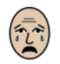  Things that might upset me
  My pets |   How I keep calm |   My phone
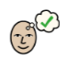  Things you might like to know about me |   My dreams for the future |   What I like about Orpheus

SECTION 8: APPLICANT SPECIAL EDUCATIONAL NEEDS
Primary Disability / Impairment:

Additional Needs: Yes ☐ No ☐

Neurodivergent conditions e.g., ASD, ADHD etc. | ☐ | Moderate/mild learning difficulty (MLD) | ☐
Speech, language and communication needs (SLCN) e.g., DLD | ☐ | Severe learning difficulty | ☐
Social, emotional and mental health needs (SEMH) | ☐ | Profound and Multiple learning difficulty (PMLD) | ☐
Sensory processing impairment | ☐ | Visual impairment | ☐
Physical disability | ☐ | Hearing impairment | ☐
Specific learning difficulty e.g., dyslexia, dyscalculia, dyspraxia etc. | ☐ | Other | ☐
Are you a wheelchair user? |  | Yes ☐  No ☐

SECTION 9: YOUR ADDITIONAL SUPPORT
History of any behavioural needs, including incidents, triggers, strategies and interventions

Have you ever left your home or school/classroom without telling anyone? | Yes ☐ No ☐  If yes, please give details:
Details of any mental health, emotional and wellbeing needs, and support required.

Is there any other information you would like us to know?

Orpheus is an open-site and is situated in a rural location surrounded by fields and woodland, together with direct and close access to the M25.  I understand that Orpheus is an open-site and wish to proceed with my application. | Yes ☐ No ☐

SECTION 10: YOUR HEALTH
Current Health needs

Past Medical history

Your Health | Tick one | Please give full details
Do you have any past or planned surgeries? | Yes ☐  No ☐
Do you have seizures?  If yes, please provide your current Epilepsy Care Plan | Yes ☐  No ☐
Do you require invasive medical treatment? E.g., suppositories, enema, injections, gastrostomy etc. | Yes ☐  No ☐
SUPPORTED HOUSING APPLICANTS ONLY  Do you need support regularly throughout the night? | Yes ☐  No ☐

SECTION 11: PRESCRIBED MEDICATION
Name of prescribed Medication including emergency medication e.g., EpiPen | Dosage | Time/s Taken | To Treat
Any other information regarding your medication:

This is me

Hello! Help us get to know you by filling out these boxes.
You can write, draw or add pictures

  Food I like |   Food I dislike
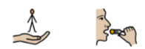  Support I need to eat | 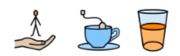  Support I need to drink
  Are you a choking risk? | 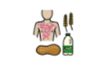  Do you have any food allergies?
  Support I need to keep myself clean at college | 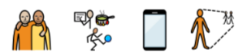  At break times I like to….

SECTION 12: YOUR PERSONAL SUPPORT DURING THE COLLEGE DAY
Describe how you like to be supported when accessing the toilet

Your Personal Support | Tick one | Please give full details
Do you require a Closomat toilet? | Yes ☐  No ☐
Do you require support with your menstrual cycle? | Yes ☐  No ☐
Do you require support with moving and handling? | Yes ☐  No ☐
Do you require 1:1 support during break and lunch times, including getting around the college? | Yes ☐  No ☐

SECTION 13: LIFESKILLS (SUPPORTED HOUSING APPLICANTS ONLY)
Describe what household chores you help with at home e.g., cooking, cleaning etc.

How much support do you need with the following:
Kitchen
Lifeskills | Full | Some | None
Menu Planning | ☐ | ☐ | ☐
Writing a shopping list | ☐ | ☐ | ☐
In the Supermarket | ☐ | ☐ | ☐
Online shopping | ☐ | ☐ | ☐
Unpacking shopping | ☐ | ☐ | ☐
Storing shopping | ☐ | ☐ | ☐
Making hot and cold food | ☐ | ☐ | ☐
Making a hot or cold drink | ☐ | ☐ | ☐
Storing food safely | ☐ | ☐ | ☐
Checking use by dates | ☐ | ☐ | ☐
Using sharp knives | ☐ | ☐ | ☐
Using oven / hob / air fryer / microwave | ☐ | ☐ | ☐
Using toaster | ☐ | ☐ | ☐
Using kettle | ☐ | ☐ | ☐
Making healthy eating choices | ☐ | ☐ | ☐
Washing up | ☐ | ☐ | ☐
Living room / bedroom
Lifeskills | Full | Some | None
Cleaning your flat | ☐ | ☐ | ☐
Laundry | ☐ | ☐ | ☐
Hanging up clothes | ☐ | ☐ | ☐
Emptying bins | ☐ | ☐ | ☐
Making your bed | ☐ | ☐ | ☐
Changing your sheets | ☐ | ☐ | ☐

SECTION 14: MOVING AND HANDLING (SUPPORTED HOUSING APPLICANTS ONLY)
Orpheus Domiciliary Services has a ‘no lifting’ policy
Do you need support with moving and handling? | Yes ☐ No ☐  If yes, please give details:
Can you independently walk up and down a flight of stairs safely? | Yes ☐ No ☐  If no, please give details:
Can you use a lift independently? | Yes ☐ No ☐  If no, please give details:
List any specialist equipment that you use e.g., walker, standing frames etc.
Do you use a manual wheelchair? | Yes ☐ No ☐  If yes, please give the following details:  Service Contract Details:  Email:  Telephone:
Do you use an electric wheelchair? | Yes ☐ No ☐  If yes, please give the following details:  Service Contract Details:  Email:  Telephone:
How many people do you need to support you with moving and handling? | Morning e.g., 1:1, 2:1 etc. | During the day / toilet e.g., 1:1, 2:1 etc. | Evening e.g., 1:1, 2:1 etc.
Do you use a hoist to transfer? | Yes ☐ No ☐  If yes, please give details:
Describe how you move from the floor to a chair:

Describe how you move from a chair to another chair/toilet:

Describe how you move from bed to a chair:

Do you need support to go to the toilet? | Yes ☐ No ☐  If yes, please give details:
Describe how you like to be supported at mealtimes:

Do you need support during the night? | Yes ☐ No ☐  If yes, please give details:
Do you need support to get undressed and into bed? | Yes ☐ No ☐  If yes, please give details:
Do you have any bed equipment such as knee pads, special pillows etc.? | Yes ☐ No ☐  If yes, please give details:
Any other moving and handling information that we need to know:

MY CONSENT

In order to obtain documents to support my application to Orpheus, I give consent for Orpheus staff members to contact my:

- Parent / Carer
- Past / Current School / College / Provider
- Local Authority Caseworker
- Social Worker / Care Manager
- Careers Advisor / Education Placement Officer

Signed:  Print Name: | Date:
Countersigned by parent / carer:  Print Name: | Date:

