APPLICATION FORM
2026-27
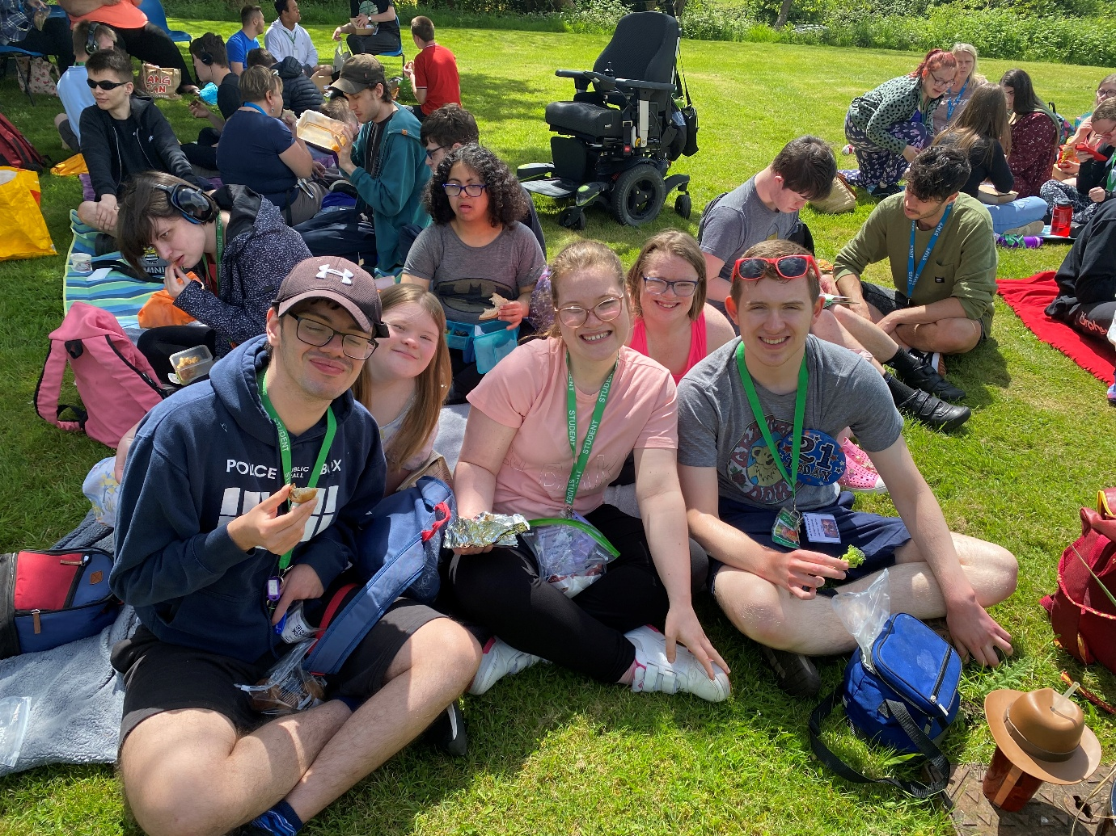

Contents
APPLICATION FOR A PLACEMENT AT ORPHEUS 3
TYPE OF PLACEMENT APPLIED FOR AT ORPHEUS 3
SECTION 1: APPLICANT PERSONAL DETAILS 3
SECTION 2: PERSONAL STATUS 4
SECTION 3: PARENT/CARER CONTACT DETAILS 4
SECTION 4: MENTAL CAPACITY ASSESSMENT 5
SECTION 5: LASTING POWER OF ATTORNEY 5
SECTION 6: COURT OF PROTECTION 5
SECTION 7: LOCAL AUTHORITY (LA) CONTACT DETAILS 6
SECTION 8: APPLICANT SPECIAL EDUCATIONAL NEEDS 7
SECTION 9: APPLICANT EDUCATION DETAILS 8
SECTION 10: ABOUT YOU 9
SECTION 11: YOUR EDUCATION SUPPORT NEEDS AND PROVISION 11
SECTION 12: YOUR INTEREST IN ORPHEUS 12
SECTION 13: YOUR THERAPIES AND EQUIPMENT 13
SECTION 14: YOUR ADDITIONAL SUPPORT 14
SECTION 15: GP DETAILS 15
SECTION 16: YOUR HEALTH 16
SECTION 17: PRESCRIBED MEDICATION 17
SECTION 18: OTHER MEDICATION 18
SECTION 19: YOUR DIET 19
SECTION 20: YOUR PERSONAL SUPPORT DURING THE COLLEGE DAY 20
SECTION 21: YOUR PERSONAL SUPPORT (SUPPORTED HOUSING APPLICANTS ONLY) 21
SECTION 22: LIFESKILLS (SUPPORTED HOUSING APPLICANTS ONLY) 22
SECTION 23: LEISURE (SUPPORTED HOUSING APPLICANTS ONLY) 23
SECTION 24: MONEY (SUPPORTED HOUSING APPLICANTS ONLY) 24
SECTION 25: ASPIRATIONS (SUPPORTED HOUSING APPLICANTS ONLY) 25
SECTION 26: MOVING AND HANDLING (SUPPORTED HOUSING APPLICANTS ONLY) 26
SECTION 27: HOUSING (SUPPORTED HOUSING APPLICANTS ONLY) 28
MY CONSENT 29

APPLICATION FOR A PLACEMENT AT ORPHEUS
Date of application

Proposed year of entry | September 2026

TYPE OF PLACEMENT APPLIED FOR AT ORPHEUS
Day placement where the learner will live at home
Day placement with Supported Housing Tenancy where the learner will live at Orpheus

SECTION 1: APPLICANT PERSONAL DETAILS
Last name / Family name
First name
Preferred name

Date of Birth
Language spoken

Home address and postcode

Applicant email address

Applicant mobile number
National Insurance Number
National Health Services Number

SECTION 2: PERSONAL STATUS
Are you adopted, fostered, living in care or under special guardianship?

SECTION 3: PARENT/CARER CONTACT DETAILS
Contact details | 1 | 2
Name
Relationship to applicant
Home address and postcode

Email address

Mobile telephone number
Home telephone number

Work telephone number
Next of kin
(Yes/No)

Parental marital status

Please state which parent or parents can be contacted as appropriate
(Yes/No)

SECTION 4: MENTAL CAPACITY ASSESSMENT
Have you had a Property and Financial Mental Capacity assessment completed? | Yes/No  If yes, please list and attach details of Assessment or Reports
Have you had a Health and Welfare Mental Capacity assessment completed? | Yes/No  If yes, please list and attach details of Assessment or Reports

SECTION 5: LASTING POWER OF ATTORNEY
Is there a Lasting Power of Attorney in place? | Lasting Power of Attorney - Property & Financial  Yes/No  If yes, please attach copy of Lasting Power of Attorney documents
Is there a Lasting Power of Attorney in place? | Lasting Power of Attorney - Health & Welfare  Yes/No  If yes, please attach copy of Lasting Power of Attorney documents
Lasting Power of Attorney contact details:

SECTION 6: COURT OF PROTECTION
Is there a Court of Protection order in place? | Court of Protection Deputy - Property & Financial  Yes/No  If yes, please attach copy of Court of Protection documents
Is there a Court of Protection order in place? | Court of Protection Deputy - Health & Welfare  Yes/No  If yes, please attach copy of Court of Protection documents
Is there a Court of Protection order in place? | Court of Protection Appointee – Administer state benefits only  Yes/No  If yes, please attach copy of Court of Protection documents

SECTION 7: LOCAL AUTHORITY (LA) CONTACT DETAILS
Contact details | LA Education Caseworker | LA Social Worker
Local Authority Borough e.g., Surrey

Name

Email address

Telephone number and extension (if known)

SECTION 8: APPLICANT SPECIAL EDUCATIONAL NEEDS
Primary Disability / Impairment:

Additional Needs (Yes/No):

Neurodivergent conditions e.g., ASD, ADHD etc. |  | Moderate/mild learning difficulty (MLD)
Speech, language and communication needs (SLCN) e.g., DLD |  | Severe learning difficulty
Social, emotional and mental health needs (SEMH) |  | Profound and Multiple learning difficulty (PMLD)
Sensory processing impairment |  | Visual impairment
Physical disability |  | Hearing impairment
Specific learning difficulty e.g., dyslexia, dyscalculia, dyspraxia etc. |  | Other

SECTION 9: APPLICANT EDUCATION DETAILS
Name of current school or college

Address and postcode

Telephone number and extension (if known)

General office email address

SENCo name and email address

Personal tutor / class teacher name and email address

SECTION 10: ABOUT YOU
Height |  |  | Weight
Hair colour |  |  | Eye colour
Any distinguishing marks

My likes e.g., hobbies and interests

My dislikes

Things you might like to know about me

My family

Do you need support to keep in contact with your family? |  | Yes/No  If yes, please detail support required
Do you have any pets? |  | Yes/No  If yes, please provide details
Do you have any Cultural / Religious / Spiritual Needs? |  | Yes/No  If yes, please provide details
Do you have your own mobility vehicle? |  | Yes/No  If yes, please provide details
My friends
Do you need support to keep in contact with your friends? |  | Yes/No  If yes, please detail support required
Have you got a boyfriend or a girlfriend? |  | Yes/No
Do you need support with romantic relationships? |  | Yes/No  If yes, please detail support required
Do you have your own mobile phone? |  | Yes/No
What social media do you use? E.g., WhatsApp, YouTube, Instagram etc.
Do you need support with social media and internet safety? |  | Yes/No  If yes, please detail support required

SECTION 11: YOUR EDUCATION SUPPORT NEEDS AND PROVISION
What support do you need in the classroom? E.g., visuals, information broken down, first-next-then, sequencing, prompts, scribe etc.

How to get the best out of me:

What would you like to get better at?

Things I find difficult:

What are your favourite subjects at school/college?

Where do you like to sit in a classroom?

What kind of things would upset you?

What would you do if you felt worried or anxious?

What would you do if you felt angry or cross about something or someone?

What strategies do you use to help you feel calm?

Are there any loud noises that upset you? | Yes/No  If yes, please give details
If loud noises upset you, what helps you when you hear these noises?

SECTION 12: YOUR INTEREST IN ORPHEUS
Why do you want to attend Orpheus?

What are your aspirations for the future? E.g., jobs, independent living etc.

What skills do you think you need to develop so that you can achieve your aspirations?

Please tell us about any creative work that you have made or been involved in in the last 3 years e.g., films, paintings, sculptures, performances, exhibitions etc.

SECTION 13: YOUR THERAPIES AND EQUIPMENT
What therapies do you currently receive and how often?

Therapy | Yes/No | How often
Speech and Language Therapy
Occupational Therapy
Physiotherapy
Psychotherapy
Counselling
Wellbeing / Pastoral support
Dramatherapy
Music Therapy
Animal Therapy
Habilitation
Hydrotherapy
Rebound therapy
Other – please state:

List any and all equipment and resources that you currently use in the classroom e.g., footstools, learning software, communication devices (AAC device), specialist seating, sensory regulation equipment (e.g., ear defenders), coloured overlays, magnifiers etc.

SECTION 14: YOUR ADDITIONAL SUPPORT
History of any behavioural needs and support provided including triggers, strategies and interventions

Details of current behavioural support needed, including triggers, strategies and interventions in place e.g., Behaviour Support Plans

Have you ever left your home or school/classroom without telling anyone? | Yes/No  If yes, please give details
Have you ever taken anything that didn’t belong to you? | Yes/No  If yes, please give details
History of any mental health, emotional and Wellbeing needs and support provided

Details of current mental health, emotional and Wellbeing needs including triggers, strategies and interventions in place

Is there anything else you can think of that we should know to ensure that we can keep you safe at Orpheus?

SECTION 15: GP DETAILS
Name of GP and Surgery

GP and Surgery address
Telephone number

Email address
If you move into Supported Housing, do you want to stay with your current GP? | Yes/No

SECTION 16: YOUR HEALTH
Current Health needs

Past Medical history

Your Health | Yes/No | Please give full details
Do you have any past or planned surgeries?

Do you have regular / ongoing medical appointments?

Do you have seizures? |  | If yes, please state any history since birth including medication, dates of last seizure etc.
If you have seizures, please tell us about any alert systems you have in place e.g., wristband

Do you have any allergies to medication?

Do you have any allergies to medical supplies? E.g., plasters, latex etc. |  | If yes, please confirm if you will supply appropriate alternatives.
Do you require invasive medical treatment? E.g., suppositories, enema, injections, gastrostomy etc.
Do you know when you are in pain? E.g., stomach aches etc.

Would you ask for support if you were in pain?

SECTION 17: PRESCRIBED MEDICATION
Name of prescribed Medication including emergency medication e.g., EpiPen | Dosage | Time/s Taken | To Treat
Describe how you like to be supported to take your medication:

Any other information in administering or side effects of your medication:

Any other information regarding your medication:

SECTION 18: OTHER MEDICATION
Name of PRN, vitamins and / or holistic medication | Dosage | Time/s Taken | To Treat
Describe how you like to be supported to take your medication:

Any other information in administering or side effects of your medication:

Any other information regarding your medication:

SECTION 19: YOUR DIET
What are your favourite foods?

What food do you dislike?

Your Diet | Yes/No | Please give full details
Do you require support to eat?

Do you require support to drink?

Do you use any specialist equipment to eat or drink?

Do you require support to make a hot or cold drink?

Are you at risk of choking on your food?

Do you have any difficulties with any specific foods? E.g., specific textures etc.

Do you have any food allergies?

Do you need support with portion control?

Do you need support to pay for meals?

Do you require prompts to make sure you are drinking enough water?

Do you require support to wash after eating?

Do you need support to attend lunchtime activities?

Any other dietary requirements?

SECTION 20: YOUR PERSONAL SUPPORT DURING THE COLLEGE DAY
Describe how you like to be supported when accessing the toilet

Your Personal Support | Yes/No | Please give full details
Do you require a Closomat toilet?

Do you require support with your menstrual cycle?

Do you require support with moving and handling?

Do you require 1:1 support during break and lunch times, including getting around the college?

SECTION 21: YOUR PERSONAL SUPPORT (SUPPORTED HOUSING APPLICANTS ONLY)
What time do you wake up?
What support do you need in the morning? E.g., waking up, taking meds, making breakfast, personal care, getting dressed etc.

Describe how you brush your teeth:
Describe how you like to be supported when showering or bathing:
What time do you like to eat your dinner?
What support do you need at dinner time? E.g., meds, preparing food, washing up etc.
What time do you like to go to bed?
What support do you need to prepare for bed? E.g., meds, brushing teeth, showering etc.
Do you require any support during the night? | Yes/No  If yes, please give details
Do you have a history of sleep walking? | Yes/No  If yes, please give details
What support do you need for personal grooming? E.g., shaving, brushing hair, deodorant etc.

SECTION 22: LIFESKILLS (SUPPORTED HOUSING APPLICANTS ONLY)
Describe what household chores you help with at home e.g., cooking, cleaning etc.

How much support do you need with the following:
Lifeskills | Full | Some | None
Menu Planning
Writing a shopping list
In the Supermarket
Online shopping
Unpacking shopping
Storing shopping
Making hot and cold food
Making a hot or cold drink
Storing food safely
Checking use by dates
Using sharp knives
Using oven / hob / air fryer / microwave
Using toaster
Using kettle
Making healthy eating choices
Washing up
Cleaning your flat
Laundry
Hanging up clothes
Emptying bins
Making your bed
Changing your sheets

SECTION 23: LEISURE (SUPPORTED HOUSING APPLICANTS ONLY)
If you were to become a tenant, would you be looking to continue with any extra-curricular activities that you are currently attending?
If yes, please give activity details, frequency, support required etc.

How much support do you need with the following:
Leisure | Full | Some | None
Booking activities
Attending activities

SECTION 24: MONEY (SUPPORTED HOUSING APPLICANTS ONLY)
Do you have your own bank account?

Does anyone other than you look after your money?

How much support do you need with the following:
Money skills | Full | Some | None
Budgeting
Paying Bills
Paying for food in supermarket or similar e.g., restaurants, pubs etc.
Keeping card and cash safe on site
Understanding the value of money
Using online banking

SECTION 25: ASPIRATIONS (SUPPORTED HOUSING APPLICANTS ONLY)
Have you ever stayed away from home before? | Yes/No  If yes, please give details
Do you ever spend any time alone at home? | Yes/No  If yes, please give details
Is there anything else you can think of that we should know to ensure that we can keep you safe at Orpheus?

SECTION 26: MOVING AND HANDLING (SUPPORTED HOUSING APPLICANTS ONLY)
Orpheus Domiciliary Services has a ‘no lifting’ policy
Do you need support with moving and handling? | Yes/No  If yes, please give details
Can you independently walk up and down a flight of stairs safely? | Yes/No  If no, please give details
Can you use a lift independently? | Yes/No  If no, please give details
List any specialist equipment that you use e.g., walker, standing frames etc.
Do you use a manual wheelchair? | Yes/No  If yes, please give the following details:  Service Contract Details:  Email:  Telephone:
Do you use an electric wheelchair? | Yes/No  If yes, please give the following details:  Service Contract Details:  Email:  Telephone:
How many people do you need to support you with moving and handling? | Morning e.g., 1:1, 2:1 etc. | During the day / toilet e.g., 1:1, 2:1 etc. | Evening e.g., 1:1, 2:1 etc.
Do you use a hoist to transfer? | Yes/No  If yes, please give details
Describe how you move from the floor to a chair:

Describe how you move from a chair to another chair/toilet:

Describe how you move from bed to a chair:

Do you need support to go to the toilet? | Yes/No  If yes, please give details
Describe how you like to be supported at mealtimes:

Do you need support during the night? | Yes/No  If yes, please give details
Do you need support to get undressed and into bed? | Yes/No  If yes, please give details
Do you have any bed equipment such as knee pads, special pillows etc.? | Yes/No  If yes, please give details
Any other moving and handling information that we need to know:

SECTION 27: HOUSING (SUPPORTED HOUSING APPLICANTS ONLY)
FLAT REASONABLE ADJUSTMENTS
Reasonable adjustments | Yes/No | Please give full details
Do you require a fob instead of a key to access your flat?

Do you need any adaptations in the kitchen? E.g., lower worktops etc.

Do you need any adaptations in the main living space?

Do you need any adaptations in the bathroom? E.g., grab rails etc.

Do you need a fitted shower chair?

Do you need a Closomat toilet?

TENANT CONSIDERATIONS
If someone knocked on your door, how would you answer?

How would you deal with a noisy neighbour?

What would you do if someone asked you to stop being noisy?

Would you ask for support if you felt lonely?

Do you need support to attend extra-curricular activities at Orpheus? | Yes/No  If yes, please give details
Do you smoke or vape? | Yes/No  If yes, please give details
Do you need support to read and understand your tenancy agreement? | Yes/No  If yes, please give details

MY CONSENT

In order to obtain documents to support my application to Orpheus, I give consent for Orpheus staff members to contact my:

- Parent / Carer
- Past / Current School / College
- Local Authority Caseworker
- Social Worker / Care Manager
- Careers Advisor / Education Placement Officer

Signed:  Print Name: | Date:
Countersigned by Parent/Carer:  Print Name: | Date:

